FreqDist()以一个简单的list作为输入，ConditionalFreqDist()以一个配对list作为输入。

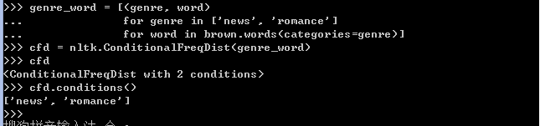

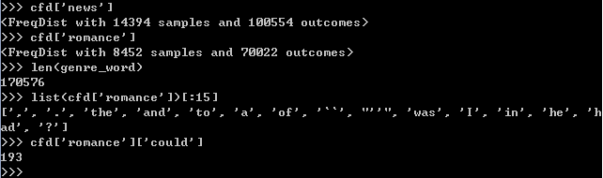

绘制分布图和分布表

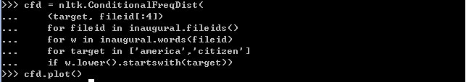

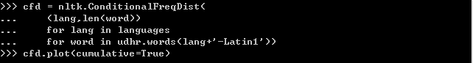

在plot()和tabulate()方法中，可以使用conditions=参数来制定显示哪些条件。同样，可以使用sample=参数来限制展示的样本

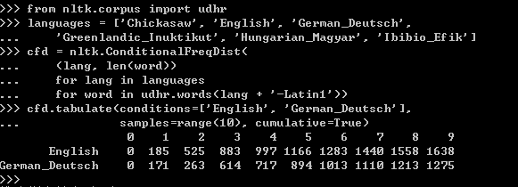

使用双连词生成随机文本

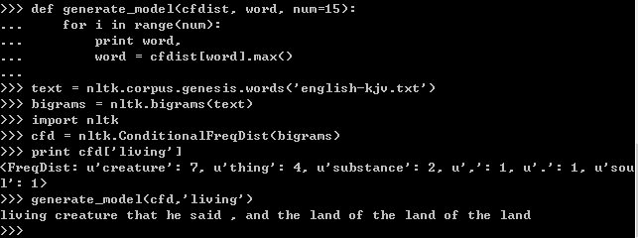

这个例子将创世纪的每两个相连的词作为一个词对并建立频率分布，然后从一个词开始，选取这个词后面出现次数最多的词做为下一个词，以此类推产生一个句子。这样可以产生有这本书风格的随机文本。

**Table 2.1**:

NLTK's Conditional Frequency Distributions: commonly-used methods and idioms for defining, accessing, and visualizing a conditional frequency distribution of counters.

|  |  |
| --- | --- |
| Example | Description |
| cfdist = ConditionalFreqDist(pairs) | create a conditional frequency distribution from a list of pairs |
| cfdist.conditions() | the conditions |
| cfdist[condition] | the frequency distribution for this condition |
| cfdist[condition][sample] | frequency for the given sample for this condition |
| cfdist.tabulate() | tabulate the conditional frequency distribution |
| cfdist.tabulate(samples, conditions) | tabulation limited to the specified samples and conditions |
| cfdist.plot() | graphical plot of the conditional frequency distribution |
| cfdist.plot(samples, conditions) | graphical plot limited to the specified samples and conditions |
| cfdist1 < cfdist2 | test if samples in cfdist1 occur less frequently than in cfdist2 |